Sunday | Monday | Tuesday | Wednesday |  | Thursday | Friday | Saturday
 |  |  |  |  | 1  Canada Day | 2 | 3
4  Independence Day (US) | 5 | 6 |  | 7 | 8 | 9 | 10
11 | 12 | 13 |  | 14 | 15 | 16 | 17
18 | 19 | 20 |  | 21 | 22 | 23 | 24
25 | 26 | 27 |  | 28 | 29 | 30 | 31

Summit House Assisted Living |  |  |  | 10:00 Exercise  1:00 Bible Study  2:00 Sing Along  Postal Worker Day | 10:00 Exercise  1:00 King’s Corner  2:00 4th of July Bingo | 1:30 Dominoes  Rubee celebrating her birthday with cake at lunch.
9:00 Church  9:30 Communion  1:30 Movie  6:00 Sparklers Outside | No Exercise  1:30 MOVIE | 10:00 Exercise  1:00 History Lesson-Mammoth Cave  2:00 Mouse Toss | No Exercise  10:00 Church  1:00 Rummikub  2:00 Sumr. Bingo  5:30-7 Island Fever Band  Summer BBQ | 10:00 Exercise  1:00 Bible Study  2:00 Balloon Tennis | 10:00 Exercise  1:30 Skip-Bo  3:30 Shut the Box | 1:30 King’s Corner
9:00 Church  9:30 Communion  1:30 UNO | 10:00 Exercise  1:00 Garbage  2:00 Barn Facts  3:00 Tenant Meeting | 10:00 Exercise  1:00 Bird History  1:30 Bird Bingo  Bird Puzzles | 10:00 Exercise  1:00 UNO Cards  2:30 Jeff Buege  Gospel Singer | 10:00 Exercise  1:00 Bible Study  2:00 Sing Along | 10:00 Exercise  1:00 Minute to Win It!  2:00 Dominoes | 1:30 MOVIE
9:00 Church  9:30 Communion  1:30 Shut the Box | 10:00 Exercise  1:30 Flip-It Cards  3-4 Smores | 10:00 Exercise  1:30 Fun Facts  2:00 Summer Bingo | Black & White  Day  10:00 Exercise  1:30 Crafts  3:00 July Birthday  Party | 10:00 Exercise  1:00 Bible Study  2:00 Skip-Bo | 10:00 Exercise  10:30 Music Therapy/Talia  1:00 Senior Summer Olympics | 1:30 Dominoes
9:00 Church  9:30 Communion  1:30 MOVIE | Red Shoe Day  10:00 Exercise  1:30 Family Feud  3:30 Coloring | 10:00 Exercise  1:30 Bean Bag Toss  3:30 Newsletter | 10:00 Exercise  1:30 Olympics Bingo  3:00 Lemonade and Cookies | 10:00 Exercise  1:00 Bible Study  2:00 Sing Along | 10:00 Exercise  1:30 Skip-Bo  3-4 Happy Hour | 1:30 King’s Corner
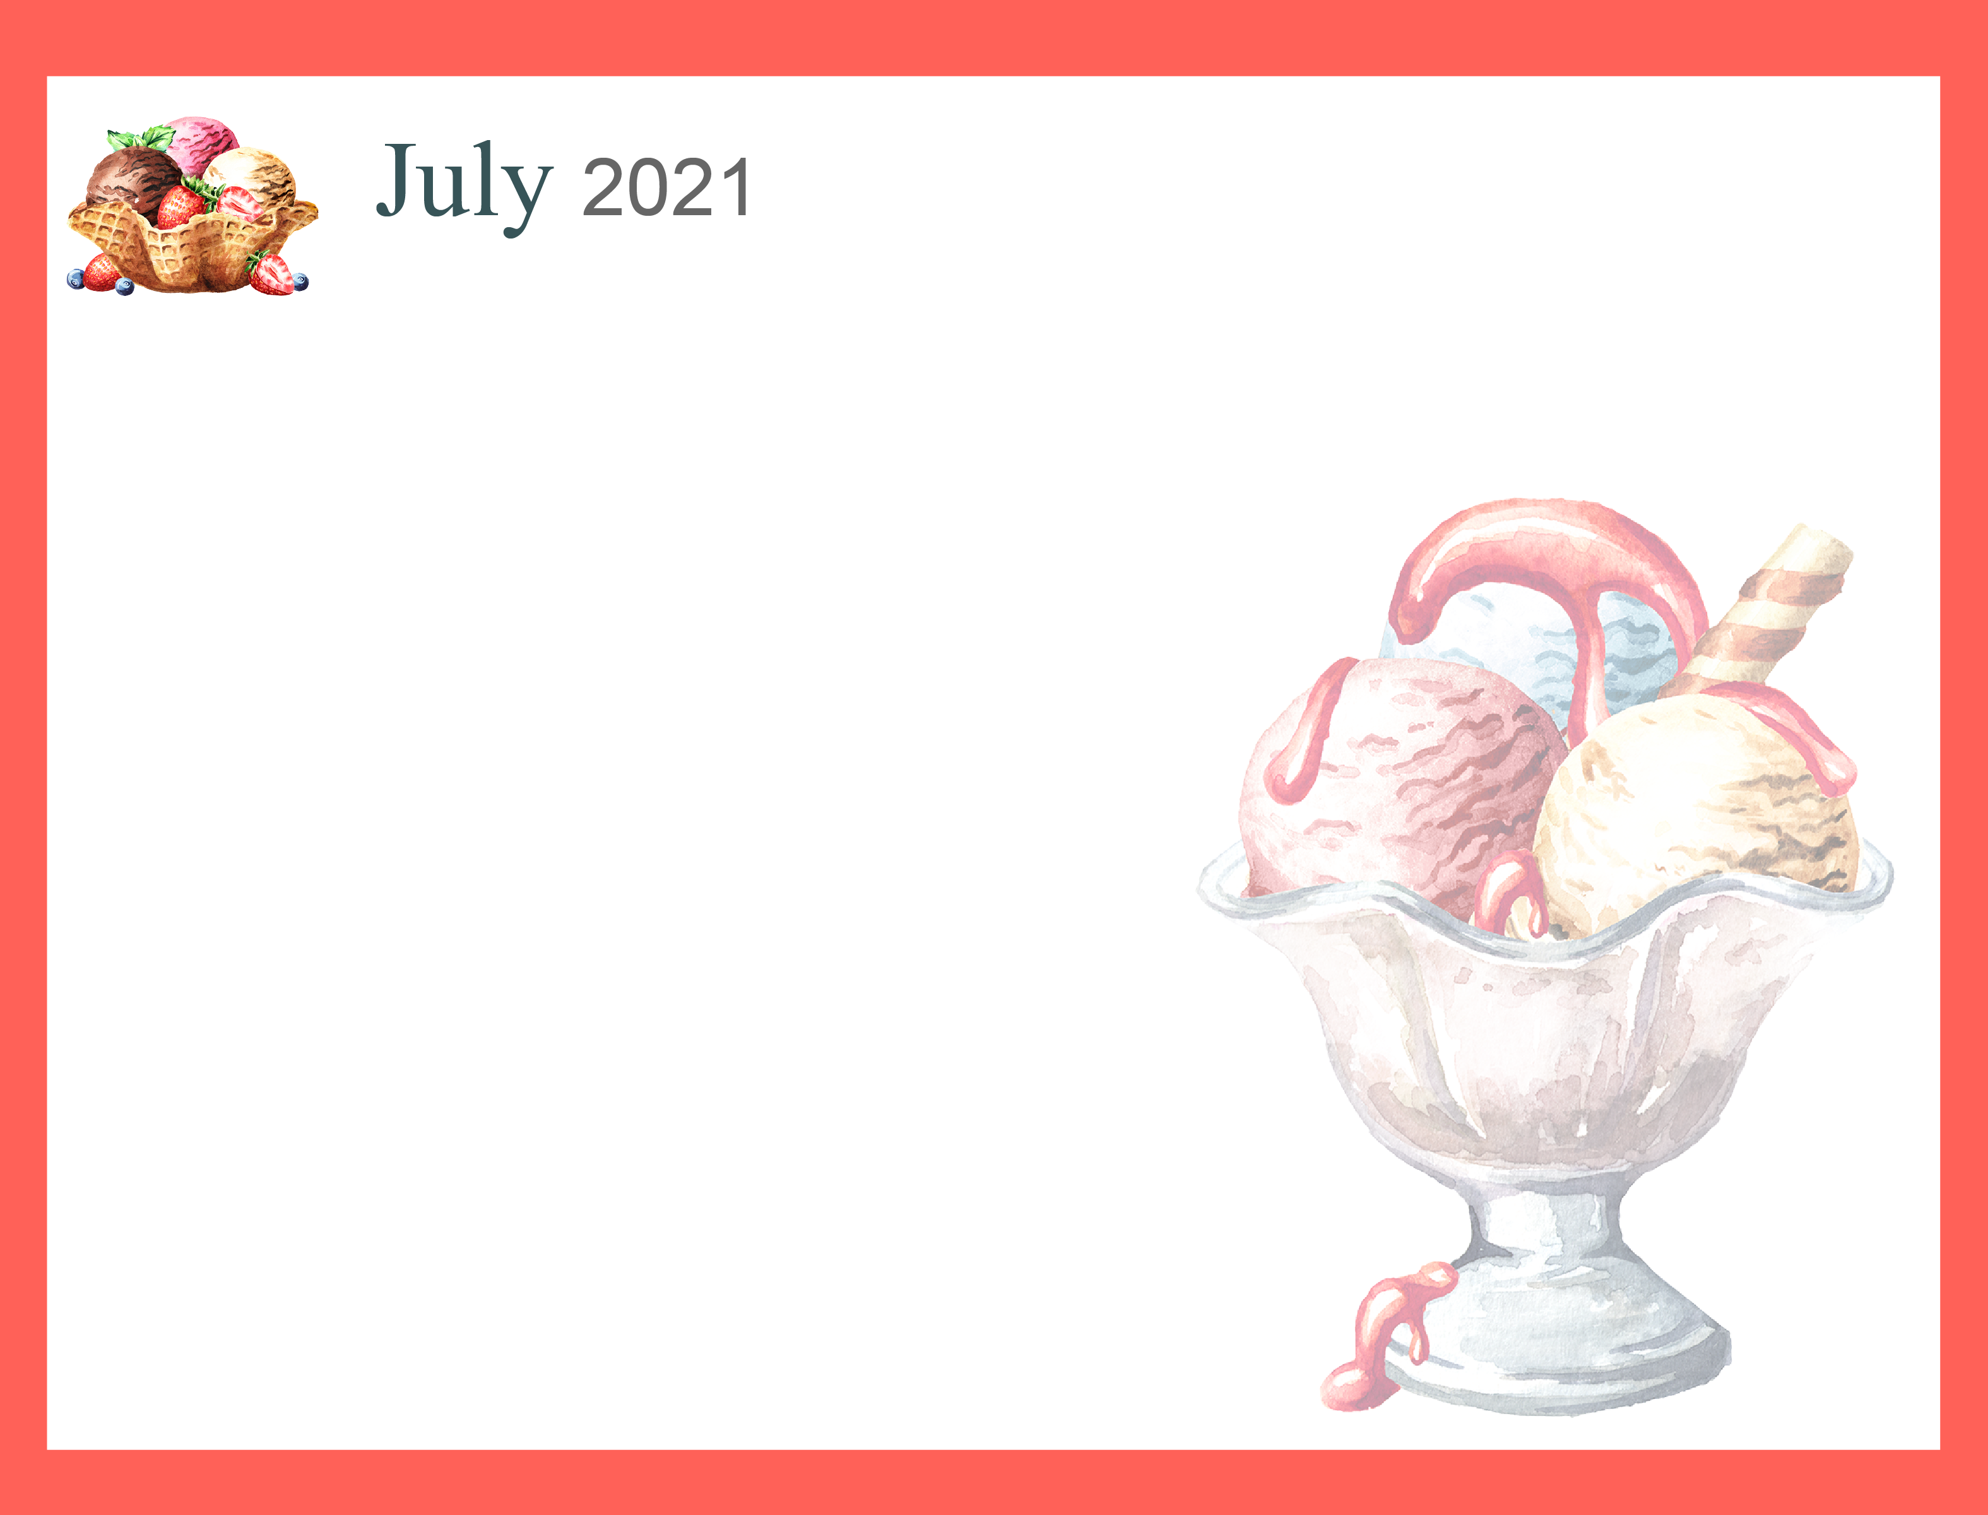
ALL ACTIVITIES ARE SUBJECT TO CHANGE WITHOUT NOTICE!

