Sunday | Monday | Tuesday | Wednesday | Thursday | Friday | Saturday
 |  |  |  |  | 1 | 2
3 | 4 | 5 | 6 | 7  Hanukkah Begins | 8 | 9
10 | 11 | 12 | 13 | 14 | 15 | 16
17 | 18 | 19 | 20 | 21  Winter Begins | 22 | 23
24 | 25  Christmas | 26  Boxing Day (Canada)  Kwanzaa Begins | 27 | 28 | 29 | 30
31

New Year’s Eve

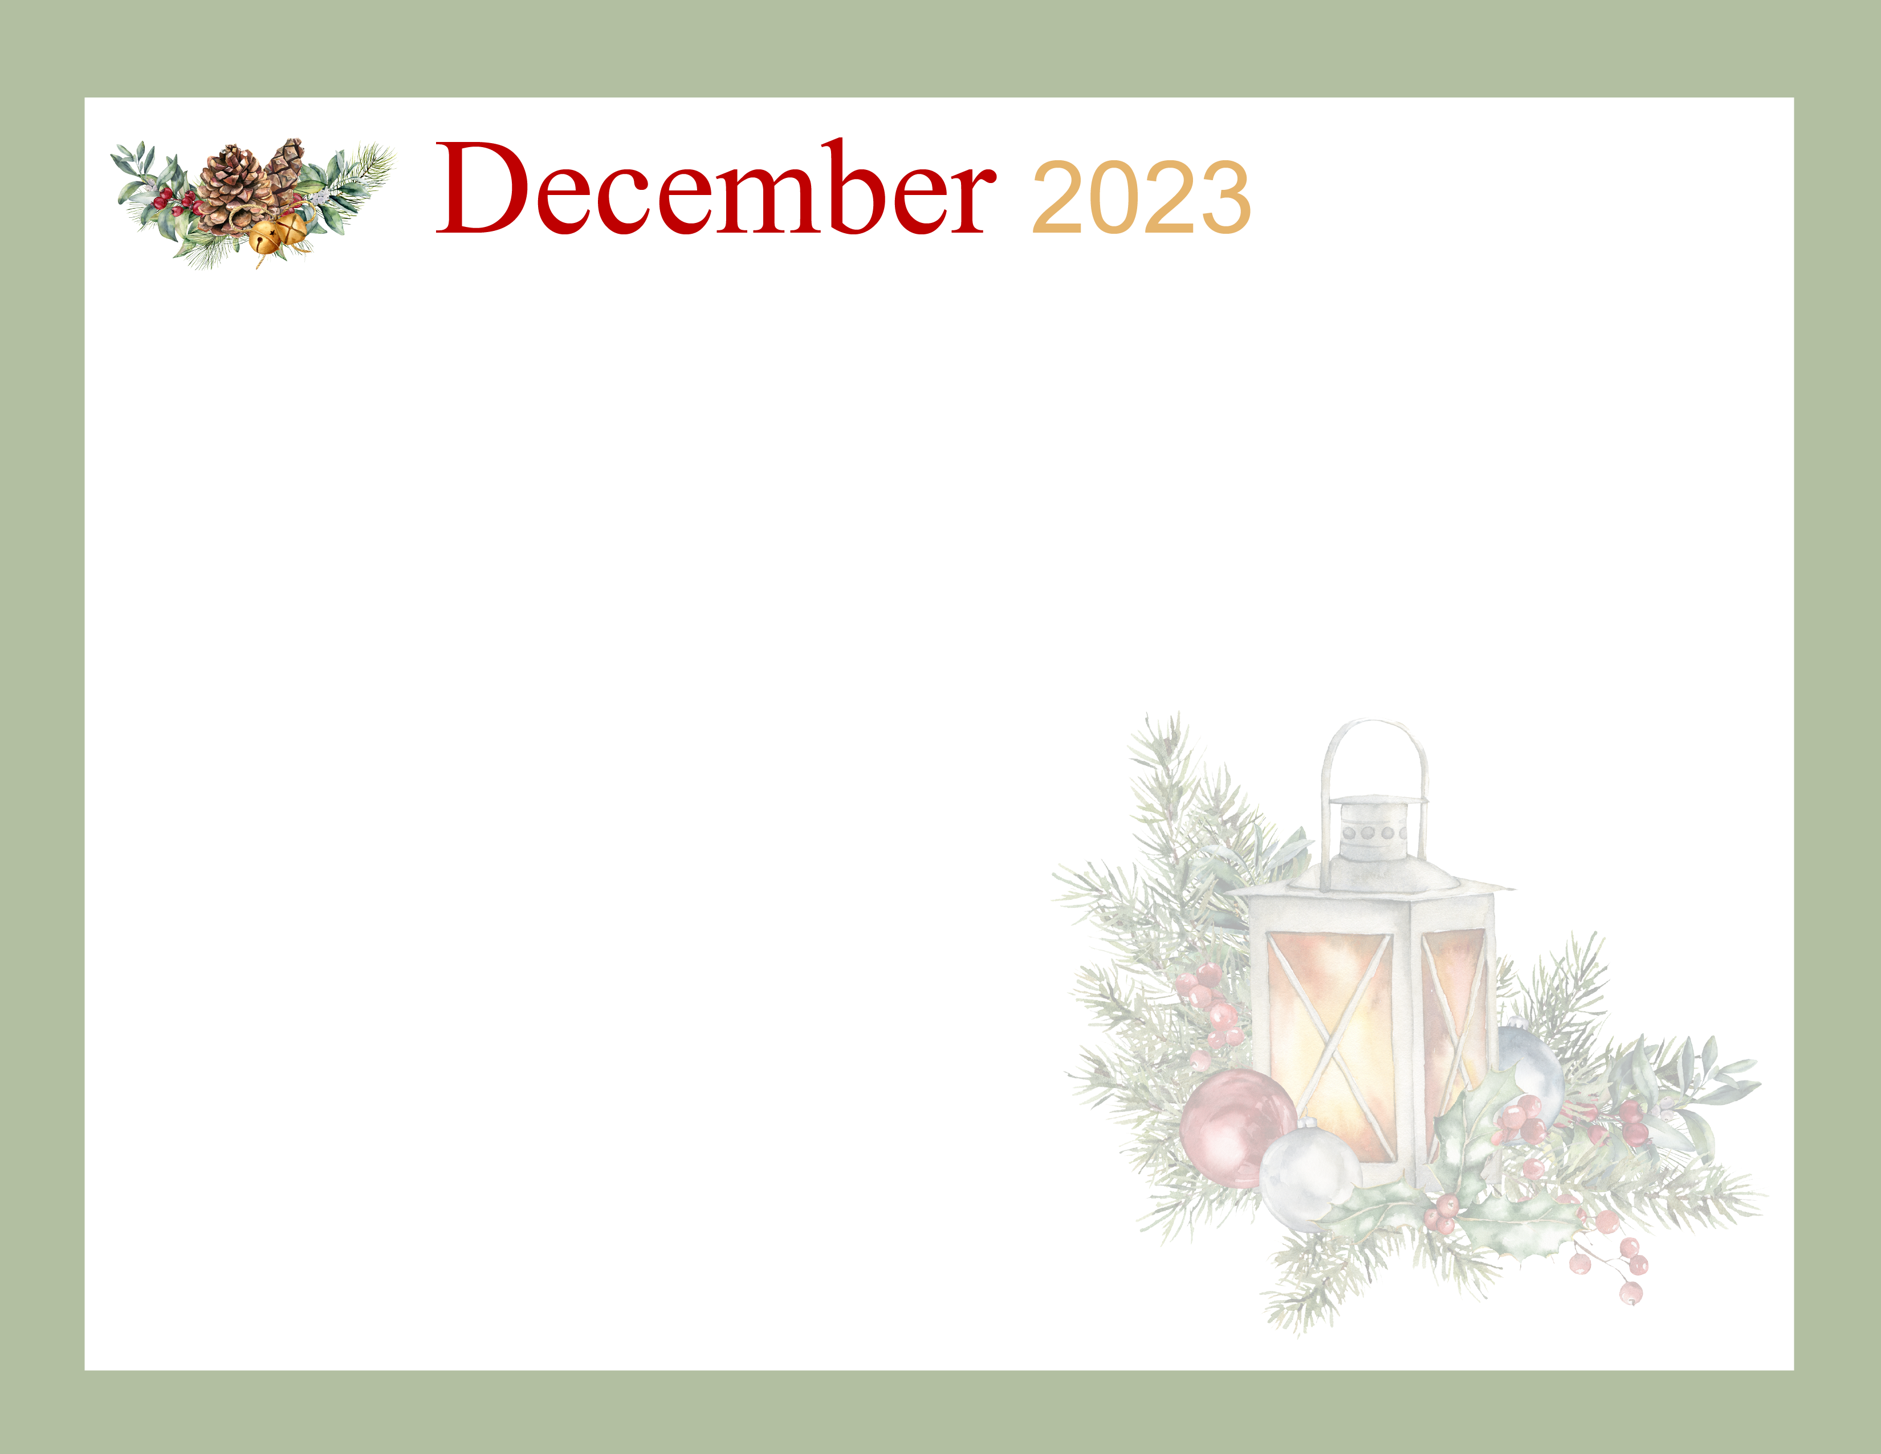  SUMMIT HOUSE ASSISTED LIVING |  |  |  |  | 9:00 Community Coffee  10:30 Exercise  1:30 Bingo  3:30 Book Club | 1:30 Skip-Bo
9:00 Church  9:30 Communion  1:30 UNO | 10:00 Exercise  11:00 Fun Facts  1:30 Flip-It  3:30 Book Club | 10:00 Exercise  10:30 B. Tennis  1:30 Xmas Crafts  3:30 Shut the Box | 10:00 Cath. Mass  11:00 Exercise  1:00 Bean Bag  6:45 Carolers in the Lobby. | 10:00 Exercise  10:30 B. Tennis  1:00 Bible Study  2:00 Sing Along | 9:00 Community Coffee  10:30 Exercise  11:00 Massages  1:30 Garbage  3:30 Book Club | 1:30 Skip-Bo
9:00 Church  9:30 Communion  2:00 Hymn Sing | 10:00 Exercise  11:00 Fun Facts  1:30 Skip-Bo  3:30 Coloring | 10:00 Exercise  10:30 B. Tennis  1:30 Make Gingerbread crafts | 10:00 Exercise  10:30 Massages  12:00 Musical Chairs  1:00 Bingo  2:00 Jeff Buege | 10:00 Exercise  10:30 B. Tennis  1:00 Bible Study  2:00 Sing Along | 9:00 Community Coffee  10:30 Exercise  1:30 Family Feud  6:00 Xmas Fun in the lobby. | 1:30 Skip-Bo
1:30 Balloon Tennis | 10:00 Exercise  11:00 Fun Facts  1:30 Movie-Silent Night Algona  3:30 Hot Cocoa | 10:00 Exercise  10:30 B. Tennis  1:30 Summit House Xmas Bakeoff.  3:00 Pastor John | 10:00 Exercise  10:30 Music Therapy  1:00 Brain Games  2:00 Nords | 10:00 Exercise  10:30 B. Tennis  1:00 Bible Study  2:00 Xmas Sing Along  6:00 Bunco | 9:00 Community Coffee  10:30 Exercise  11:00 Massages  1:30 Xmas Bingo  3:00 Xmas Treats | 1:30 Skip-Bo
1:30 UNO | MERRY CHRISTMAS  1:30 Skip-Bo  Location TBD | 10:00 Exercise  10:30 Balloon Tennis  1:30 Flip-It  2:30 Tenant Mtg. | 10:00 Exercise  10:30 Singing Cowgirl  1:30 Garbage  3:00 Pastor John | 10:00 Exercise  10:30 B. Tennis  11:00 Massages  1:00 Bible Study  2:00 Sing Along | 9:00 Community Coffee  10:30 Exercise  2:30 New Years treats & drinks. | 1:30 Skip-Bo
1:30 Balloon Tennis | MERRY CHRISTMAS AND HAPPY NEW YEAR!
ALL ACTIVITIES ARE SUBJECT TO CHANGE WITHOUT NOTICE.

